מטלה 1
מבוא לתכנות מערכות:
מגישים:
משה פרץ- 318263977
נעמי דורטנזי- 328629886

תרגיל 1
קוד:
#define _CRT_SECURE_NO_WARNINGS
#include <stdio.h>
#include <stdlib.h>
#include <string.h>
#include <math.h>
#define MAX 9
typedef struct fraction
{
int a;
int b;
}fraction;

void calculate(fraction* s, int size);
void inputInfo(fraction* s, int size);
void main()
{
fraction Fractions[MAX];
fraction* p = &Fractions[0];
inputInfo(p, MAX);
}
/*
Function name: calculate
Input: getting the fraction struct and the quatity of the fractions
Output: outputting the smallest fraction possible
Algoritem: first it counts the mone and the mehane together by the rules
to one fraction, then the fucntion finds the highest number that
divide them both
*/
void calculate(fraction* s, int size)
{
int i, count = 0;
long int t, mehaneX, moneX, moneY, mehaneY;
long int mehane = s[0].b;
long int mone = 0;
for (i = 1; i < size; i++)//calculates the common division
mehane = mehane * s[i].b;
for (i = 0; i < size; i++)// calculates the entire fraction
mone = mone + s[i].a * (mehane / s[i].b);
for (i = 0; i < size; i++)
printf(" %d/%d %c", s[i].a, s[i].b, (i == size - 1) ? '=' : '+');
//for not losing the original number
moneX = abs(mone);
mehaneX = abs(mehane);
/*calculates the highest number that divides both mone and mehane
and put it in moneX */
do {
t = moneX % mehaneX;
if (2 * t > mehaneX)
t = mehaneX - t;
moneX = mehaneX;
mehaneX = t;
} while (moneX != 0 && mehaneX != 0);
mone = mone / moneX;//reduction the mone and mehane by the highest common number
mehane = mehane / moneX;
printf(" %ld/%ld = ", mone, mehane);
moneY = abs(mone);
mehaneY = abs(mehane);
while (moneY > mehaneY)//count the quantities of the integers
{
moneY = moneY - mehaneY;
count++;
}
mehane = mehaneY;
if (mone < 0) {
moneY = moneY * -1;
count = count * -1;
}
if (abs(count) > 0)
printf("%ld and", count);
printf(" %ld/%ld\n", moneY, abs(mehane));
}
/*
Function name: outputInfo
Input: getting the fraction struct and the quantity of the fractions
Output: outputting the smallest fraction possible
Algorithm: it first getting input all the fraction from the user and put them
into the structure array and send the array to the calculate function
*/
void inputInfo(fraction* s, int size)
{
int i, index;
printf("Enter fractions(max 9) by pairs of integers(0 0 to finish):\n");
for (i = 0, index = 0; i < size; i++, index++)
{
printf("%d (mone mehane): ", i + 1);
scanf("%d%d", &s[i].a, &s[i].b);
//checking if the fraction is correct and valid
while (s[i].a != 0 && s[i].b == 0)
{
printf("invalid denominator,please try again!\n");
scanf("%d%d", &s[i].a, &s[i].b);
}
if ((s[i].a == 0) && (s[i].b == 0))
i = size;
}
if (index < i)
calculate(s, index - 1);
else
calculate(s, i);
}
פלט:
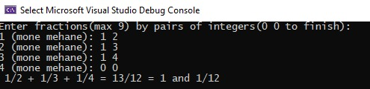
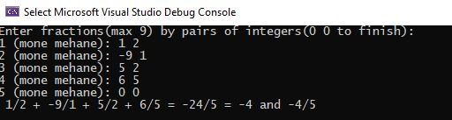
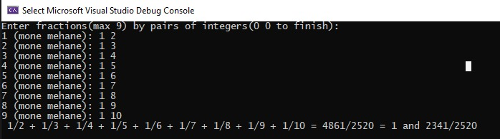
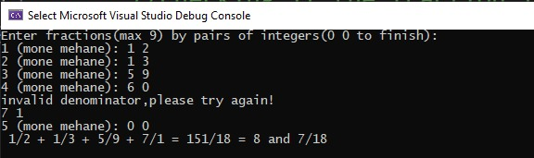

תרגיל 2
קוד:
#define _CRT_SECURE_NO_WARNINGS
#include <stdio.h>
#include <stdlib.h>
#include <string.h>

#define N 4
#define MAX 150

typedef struct Department {
char code[10];
char* name;
int soldItems;
}Depart;

void newDepart(Depart* depart);
void pointOrder(Depart** departP, Depart* depart);
void printWinLoseDepart(Depart** depart);
void CheckStrings(char* s, unsigned int size, char* name);
void NoMemory();

int main() {
int i;
Depart department[N];
Depart* departmentP[N];

for (i = 0; i < N; i++) {
newDepart(&department[i]); //collect information about every department
departmentP[i] = &department[i]; //Add to the array pointer the adress of the every department
}
pointOrder(departmentP, department); //order the departments
printWinLoseDepart(departmentP); //print the best and wrost departments
for (i = 0; i < N; i++)
free(department[i].name);
return 0;
}
//Function that collect the infromation about the department from the user
void newDepart(Depart* depart) {
char name[MAX];
printf("Enter class code: ");
scanf("%s", depart->code);
CheckStrings(depart->code, 10, "code");
printf("Enter class name: ");
rewind(stdin);
scanf("%s", name);
CheckStrings(name, 20, "name");
depart->name = (char*)malloc((strlen(name) + 1) * sizeof(char));
if (depart->name == NULL)
{
free(depart->name);
NoMemory();
}
strcpy(depart->name, name);
printf("Enter amount of sold items: ");
scanf("%d", &depart->soldItems);
}
/*checking if the string did not exceed the size limited to them*/
void CheckStrings(char* s, unsigned int size, char* name)
{
while (strlen(s) > size)
{
printf("\ninvalid %s!-the %s is too long,please try again\n", name, name);
printf("Please enter the %s (max %d): \n", name, size);
rewind(stdin);
scanf("%s", s);
}
}
/*Function that change the order of the pointers by putting the best department on the
first place in the pointers array and putting the worst department on the second place
of the pointers array*/
void pointOrder(Depart** departP, Depart* depart) {
int i;
int bestSales = departP[0]->soldItems, badSales = departP[0]->soldItems;
Depart** temp;

for (i = 1; i < N; i++) {
if (bestSales < departP[i]->soldItems) {
bestSales = departP[i]->soldItems;
temp = departP[0];
departP[0] = departP[i];
departP[i] = temp;
}
}
for (i = 1; i < N; i++) {
if (badSales > departP[i]->soldItems) {
badSales = departP[i]->soldItems;
temp = departP[1];
departP[1] = departP[i];
departP[i] = temp;
}
}
}
// Function that print the results
void printWinLoseDepart(Depart** depart) {
printf("\nThe best class is %s with code number %s\n", depart[0]->name, depart[0]->code);
printf("The wrost class is %s with code number %s\n", depart[1]->name, depart[1]->code);
}
void NoMemory()
{
printf("\nError: not enough memory");
exit(1);
}

פלט:
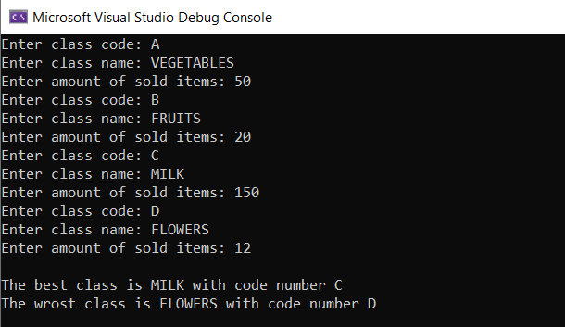

תרגיל 3
קוד:
#define _CRT_SECURE_NO_WARNINGS

#include<stdio.h>
#include<stdlib.h>
/*Clock Struct*/
typedef struct Clock
{
int hour;
int minute;
} clock_t;

void TimeAdd(clock_t* a, int minsadd, clock_t* b);
void ClockPrint(clock_t* a);
int main()
{
int minsadd;
clock_t clock, newclock;
printf("Enter time and minutes to add: ");
scanf("%d%d%d", &clock.hour, &clock.minute, &minsadd);
while (clock.hour > 24 || clock.minute >= 60)
{
printf("Input error\n");
printf("Enter time and minutes to add: ");
scanf("%d%d%d", &clock.hour, &clock.minute, &minsadd);
}
printf("\nThe time is: ");
ClockPrint(&clock);
TimeAdd(&clock, minsadd, &newclock);
printf("\nThe new time is: ");
ClockPrint(&newclock);
return 0;
}

/*Function that add time to the clock and update it */
void TimeAdd(clock_t* clock, int minsadd, clock_t* newclock)
{
newclock->minute = clock->minute + minsadd;
newclock->hour = clock->hour + newclock->minute / 60;
newclock->minute %= 60;
newclock->hour %= 24;
}
/*Function that print the clock*/
void ClockPrint(clock_t* a)
{
if (a->hour < 10)
printf("0");
printf("%d:", a->hour);
if (a->minute < 10)
printf("0");
printf("%d", a->minute);
}

פלט:
